[The NDAA Explained: Part One in a Two-Part Series of Columns on the National Defense Authorization Act](https://verdict.justia.com/2011/12/21/the-national-defense-authorization-act-explained)

21 DEC 2011 [JOANNE MARINER](https://verdict.justia.com/author/mariner)

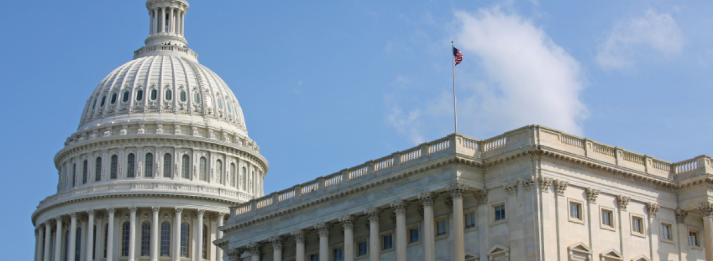

Passed by the House and Senate last week, the National Defense Authorization Act (NDAA) now awaits the president’s signature.  Because of its controversial provisions on indefinite detention, President Obama had threatened to veto the bill back in May, when the House passed one version of it, and again in November, when the Senate passed another, somewhat different version of it.

But last week, after the House and Senate reconciled their two versions of the bill, the president lifted his veto threat.  His press secretary explained in a written statement that the revised bill was considered acceptable because problematic provisions had been removed, and because “the most recent changes give the President additional discretion in determining how the law will be implemented, consistent with our values and the rule of law.”

Numerous human rights advocates, civil libertarians, and members of Congress disagree. Human Rights Watch said that President Obama’s decision not to veto the bill “does enormous damage to the rule of law both in the US and abroad.”  The ACLU said, “if President Obama signs this bill, it will damage both his legacy and American’s reputation for upholding the rule of law.” Representative Jerrold Nadler, who voted against the bill, said that it presents a “momentous challenge to one of the founding principles of the United States—that no person may be deprived of his liberty without due process of law.”

The bill’s congressional supporters reacted with outrage to such criticism, calling it false and misleading. “Rarely in my time have I seen legislation so consistently misunderstood and misrepresented as these detainee provisions,” complained Senator John McCain, one of the bill’s main drafters.

So what do the detention provisions of the NDAA actually say, and who, in particular, do they affect?

**Background to the NDAA**

To fully understand the NDAA’s provisions on detention, a brief review of recent history is needed.

During the Bush years, despite massive public and press attention to the administration’s detention policies, Congress remained largely out of the picture. While the USA PATRIOT Act contained some provisions on detention, they were never put to use; the Bush administration preferred to create a detention system that was, it assumed, largely free of legal constraints and judicial oversight.

The military prison at Guantanamo and the CIA’s secret prison system were therefore created by executive fiat, without congressional input or restriction. When cases challenging Guantanamo and the military detention of US citizens on US soil got to court, however, the administration claimed that the Authorization for Use of Military Force (AUMF), a joint resolution passed by Congress in September 2001, gave congressional approval for those detentions.

The AUMF, which authorizes the president to use “necessary and appropriate force” against those whom he determined “planned, authorized, committed or aided” the September 11 attacks, or who harbored such persons or groups, is silent on the issue of detention. A plurality of the US Supreme Court agreed with the administration, nonetheless, that the power to detain is necessarily implied by the power to use military force.

[*Hamdi v. Rumsfeld*](http://supreme.justia.com/cases/federal/us/542/03-6696/), the 2004 ruling that upheld the US government’s detention power, left many questions unanswered.  Because it involved a prisoner who was captured during the armed conflict in Afghanistan, it did not raise the Bush administration’s broad claims of a “global war on terror,” in which terrorism suspects far from any battlefield were treated like enemy soldiers.  It did not even give much guidance regarding the scope of the armed conflict, geographic or temporal, although it included, in dicta, a skeptical reference to the administration’s broadest claims.

Congress maintained its hands-off approach to detention during the entirety of President Bush’s two terms in office, even as it legislated on closely related issues like minimum standards of humane treatment and the rules for military commission proceedings.  When Obama took office in January 2009, however, Congress’s attitude changed.  Many members of Congress reacted negatively to Obama’s stated goal of closing Guantanamo, and, since that time, Congress has imposed various ever tighter restrictions on the release and transfer of detainees.

One last historical fact that is important to remember, when considering the scope of the NDAA, is that the Bush administration held two American citizens in indefinite military detention, Yaser Hamdi and Jose Padilla.  While Hamdi was picked up as a combatant in Afghanistan in 2002, Padilla was arrested in a civilian setting in Chicago that same year.  The Padilla case was never definitively adjudicated—Padilla was finally moved to the civilian justice system in 2006 — but it underscores the Bush administration’s claim of power to hold even American citizens picked up in the United States indefinitely without trial.

**Subtitle D of the NDAA**

What is now known as Subtitle D of the NDAA—the section on detention—made its first appearance in March of this year.  Called the Detainee Security Act in the House, and the Military Detainee Procedures Improvement Act in the Senate, the bills, introduced by Representative Buck McKeon and Senator John McCain, respectively, were meant to shift counterterrorism responsibilities from law enforcement to the military. The clear goal of the two bills was to require that suspected terrorists either be tried before military commissions or be held in indefinite detention without charge.

By May, the House version of the bill had been added to the NDAA, a $662 billion spending bill that finances the military’s annual operations.  It passed by a vote of 322-96, even as President Obama issued a veto threat, complaining that the bill improperly limited the government’s ability to fight terrorism effectively.

The Senate version of the bill, which also became part of the NDAA, passed in November on an overwhelming 93-7 vote.  Prior to the Senate’s passage of the bill, nearly every government official with responsibility over counterterrorism, from FBI head Robert Mueller to CIA director David Petraeus, had voiced concerns that the bill would have a negative impact on US counterterrorism efforts.

President Obama again issued a veto threat after the Senate vote, but as soon as the bill was modified slightly during the process of reconciling its House and Senate versions, the threat was dropped.  The final version of the bill passed both houses of Congress last week with large majorities.

**Substance and Procedure in the NDAA**

Subtitle D of the NDAA consists of twelve sections, covering issues that range from the military’s power over detention to technical amendments to the Military Commissions Act of 2009. Overall, the thrust of its provisions is to create a presumption of military jurisdiction over terrorism suspects, expand post-hoc congressional scrutiny of decisions over the detention and prosecution of such suspects, and effectively prevent Guantanamo from being closed.

Rather than establishing categorical rules to achieve these ends, however, the bill mostly relies on an array of procedural techniques like reporting, briefing and certification requirements.  The substantive rules that it does establish are, in large part, qualified by waiver options and other potential loopholes.

Nonetheless, nearly every provision in subtitle D is objectionable from the standpoint of human rights and civil liberties.  Among the controversial provisions are sections 1026, 1027 and 1028 of the bill, which restrict detainee transfers and releases from Guantanamo.  But while human rights organizations are worried about these limitations, their gravest concerns pertain to sections 1021 and 1022.

**Sections 1021 and 1022**

It is sections 1021 and 1022 that human rights organizations have in mind when they say that the NDAA enshrines indefinite detention without charge into US law.

Section 1021 purports to “affirm” the military’s authority to hold people in indefinite detention without charge pursuant to the AUMF.  Although the original House version of the bill would have stated explicitly that the US continues to be in an armed conflict with Al Qaeda, the Taliban and associated groups, the final version of the bill is somewhat more circumspect.

Section 1022 takes a subset of the persons possibly subject to military detention under section 1021—focusing essentially on persons with a stronger connection to terrorism—and creates a presumption that they will be held in military detention.

The bad news is that, as passed, sections 1021 and 1022 represent clear congressional approval of what, up to now, has been solely the executive branch’s decision to hold people in indefinite detention without charge.  (Remember that the AUMF itself was silent on detention questions.)  Giving the practice a firm and explicit statutory grounding not only makes it less vulnerable to legal challenge, it may well make the practice more permanent.

The good news, to the extent there is any, is that neither section 1021 nor section 1022 defines the “war” or the “hostilities” at issue.  They do not, in other words, explicitly embrace the “global war on terror” paradigm that equates terrorism with armed conflict and suspected terrorists with enemy soldiers.  By failing to address that question, they leave open the theoretical (if unlikely) possibility that a court could give the statute a narrow reading consistent with international law understandings of armed conflict.

Yet even this qualified success should be further qualified.  First, some of the people explicitly covered by section 1021—who, for example, harbored persons responsible for the September 11 attacks—might have no meaningful link to armed conflict.

More importantly, the focus of section 1022 is clearly terrorism, not armed conflict: it covers Al Qaeda members and members of groups that act in coordination with or under the direction of Al Qaeda.  Although the people subject to presumptive military detention under section 1022 are supposed to be a subset of the larger group of people covered by section 1021, which includes a requirement of a nexus to armed conflict under its subsection (b)(2), the thrust of the provision is still to equate armed conflict with terrorism.

Finally, it should also be noted that the set of “covered persons” subject to possible military detention, as defined in section 1021(b) of the NDAA, is far broader than the set of persons mentioned in the AUMF.  While section 1021(b)(1) relies on the wording of the AUMF, section 1021(b)(2), which defines an additional category of potential detainees, is based on the Obama administration’s definition of “unprivileged enemy belligerent” (which, itself, is just a slight tweaking of the Bush administration’s definition of “unlawful enemy combatant”).

This provision covers not only persons who are members of Al Qaeda, the Taliban and associated forces (all broad and possibly inchoate categories in themselves), but also persons who “substantially supported” those groups.  The concept of “substantial support” is potentially quite broad (what kind of support is covered, and might opinion or expression count?).  Also, support is an extremely controversial basis for law of war detention, even in traditional wars, and the issue has sparked enormous litigation at Guantanamo.

**The Indefinite Detention of American Citizens**

In my next column, I will address the most vexed and contested question about the scope of the NDAA’s detention provisions:  the extent to which they authorize the detention of American citizens, including citizens picked up in the United States.

For the moment, I’ll just note some recent remarks of one of the NDAA’s key drafters.  In applauding the bill’s passage last week, Senator McCain spoke of its “strong, unambiguous language that recognizes that the war on terror extends to us at home.”